Assignment 2 (Final Version)
Topic: Responsive Sidebar + Header using Bootstrap

DO’s and DON’Ts

DO’s
• Use Bootstrap (CSS + JS) for layout and components
• Use Bootstrap Grid system (container, row, col-*)
• Use Bootstrap Icons for sidebar menu
• Ensure responsive design (mobile, tablet, desktop)
• Maintain proper alignment between sidebar, header, and content
• Use clean and structured HTML
• Use minimal custom CSS where required

DON’Ts
• ❌ Do NOT build layout using only custom CSS (Bootstrap must be used)
• ❌ Do NOT ignore responsiveness
• ❌ Do NOT break alignment between header and sidebar
• ❌ Do NOT overload with unnecessary components
• ❌ Do NOT rely completely on inline CSS (limited use allowed only for small overrides)

Layout to be Created
You must create a single integrated page layout consisting of:
- Sidebar (Left)
- Header/Navbar (Top)
- Main Content Area

Sidebar (Primary Focus)

Structure

Top Section:
• Profile image/icon
• Name or selection text

Search Section:
• Search input field

Menu Items (with Bootstrap Icons):
• Home
• Videos
• Books
• Store
• Analytics
• Settings

Functionality

Expanded Mode:
• Show icons + text

Collapsed Mode:
• Show only icons

Requirements:
• Add a toggle button to expand/collapse sidebar
• Use Bootstrap Collapse or Offcanvas
• Smooth transition between states

Interaction Requirements
• Highlight active menu item
• Add hover effect on menu items
• Maintain alignment in both expanded and collapsed states

Responsive Behavior
• On smaller screens:
- Sidebar should behave like offcanvas (hidden by default)
• On larger screens:
- Sidebar should remain visible (fixed or sticky)
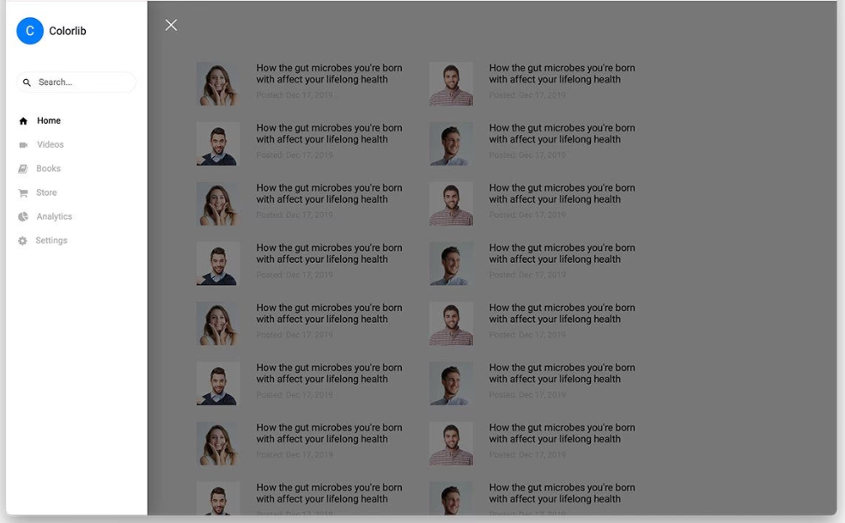
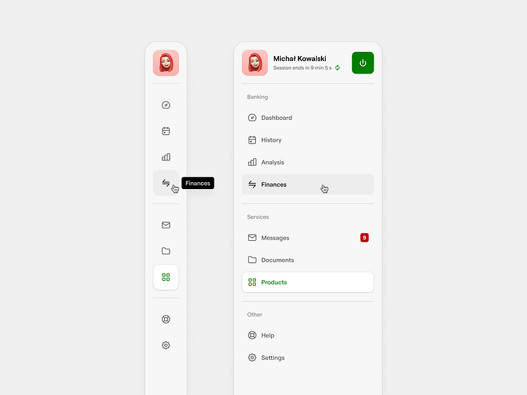

Header (Top Navbar)

Navigation Menu
• Home
• About
• Features
• Case Studies
• Pricing

Right Section
• Contact Us
• Login Button
• Profile Dropdown (Bootstrap dropdown)

Requirements
• Header must be fixed at top (fixed-top)
• Must align properly with sidebar
• Should not overlap content incorrectly

Interaction
• Contact Us or Login should open a Bootstrap Modal
• Dropdown must work properly on all screen sizes


Main Content Area (TABLE – DETAILED REQUIREMENT)

Layout Requirement
• Use Bootstrap Grid system
• Use:
- container-fluid
- row
- col-*
• Table should take only the available width of the screen
• Table width must dynamically adjust:
- When sidebar expands → table width decreases
- When sidebar collapses → table width increases

Table Objective
Create a large, data-heavy table to simulate real-world dashboard data.

Table Structure

Columns (MANDATORY – MANY COLUMNS)
Include at least:
• ID
• Name
• Email
• Role
• Department
• Experience
• Skills (multiple values)
• Project Assigned
• Project Status
• Manager Name
• Joining Date
• Last Active

Data Requirements
• Minimum 50–100 rows (static data)
• Data can be dummy/sample

Special HTML Requirements
Table must include:
• Use of:
- <thead>
- <tbody>
- <tr>
- <th>
- <td>
• Use rowspan (at least once)
• Use colspan (at least once)

Layout Behavior Requirements (VERY IMPORTANT)

Horizontal Behavior
• Table must NOT create horizontal scroll
• Table must fit within available screen width at all times
• Content inside cells should:
- Wrap into multiple lines if needed
- Expand row height instead of expanding table width
👉 This ensures:
• Proper handling of long text
• Real-world responsive table behavior

Vertical Behavior
• Table should support vertical scrolling when content exceeds height
• Page layout (header + sidebar) must remain intact

Table Styling
• Use Bootstrap table classes where possible
• Add:
- Borders
- Row hover effect
- Proper spacing
• Ensure readability even with:
- Large number of columns
- Multi-line cell content

⚠Important Constraints
• No horizontal scrollbar should appear for the table
• Table should not break layout at any screen size
• Content should remain readable and properly aligned

Hint (Optional for Students)
To achieve this, students may need to explore:
• Text wrapping
• Word breaking
• Responsive table behavior

Background Requirement
• Add a background image to the page
• Ensure content remains readable (use overlay if required)

Responsiveness
• Layout must adapt to:
- Mobile
- Tablet
- Desktop
• Sidebar behavior must change based on screen size
• Table:
- Should remain usable on smaller screens
- May allow scrolling if required

Technical Requirements
• Use:
- HTML
- CSS
- Bootstrap (CSS + JS)
• JavaScript:
- Only if required
- Prefer Bootstrap components

🧠 Code Quality Requirements
• Clean and readable code
• Proper indentation
• Logical component structure
• Minimal but effective custom CSS

🧪 Evaluation Criteria
Criteria
Sidebar Functionality & Behavior
Header Alignment & Positioning
Table Implementation (Structure + Data)
Responsiveness
Bootstrap Usage
Layout Adaptability (Sidebar vs Content)
Code Quality

🏁 Final Notes
• Focus on sidebar and header integration
• Table is used to test layout handling and data structure
• UI should remain clean even with large data
• Do not copy designs—improve them

